Sample Messaging - “Sound the Alarm” Campaign 1.0

Key messaging themes:
- The challenges hospitals are facing aren’t limited to COVID
- Hospitals and health care workers need public support
- Our hospital system has bent but not broken; we’re still here for our communities
- Health care workers were heroes then and they’re heroes now – more than 18 months later
- Do your part to help protect our health care resources – follow precautions
- Despite challenges, hospitals remain open and ready – do not delay care (seek the right level of care, at the right time, and at the right place)
- Protection against COVID, flu, RSV, etc. will help protect our resources

Sample messaging by theme (bolding for emphasis only):
Theme 1 - They’re still heroes
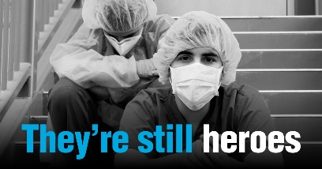
- They’re still heroes, and they need you now more than ever.
It’s time to rally behind hospitals and health care workers once again. Show your support by wearing a mask, washing your hands, watching your distance, and waiting to attend large gatherings. Learn about everyday actions that can help fight germs at https://bit.ly/2XPyjlo.

- They’re still heroes. Let them know you’re still with them.
Hospitals and health care workers need a break. You can help by wearing a mask, washing your hands, watching your distance, and waiting to attend large gatherings. Make plans to get your flu vaccine or COVID-19 vaccine booster shot today.

- They’re still heroes. Now it’s your turn.
Protect Colorado’s health care resources by wearing a mask, washing your hands, watching your distance, and waiting to join large gatherings. Stay up to date on routine care. Make plans to get your flu shot, your COVID-19 vaccine booster, or your child’s pediatric COVID-19 vaccine today. Learn about getting a flu vaccine during COVID-19 at https://bit.ly/3vVjZVk.

Theme 2 – Protect and preserve
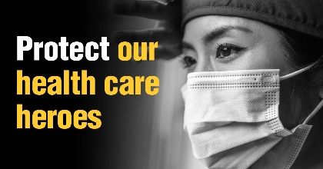
- FACT: Hospitals are filling up.
FACT: Health care staff are exhausted.
FACT: This affects us all.
FACT: You can help.
Wear a mask, wash your hands, watch your distance, and wait until it’s safe to join large gatherings. Learn about the importance of preparing for flu season amid another COVID-19 surge at https://bit.ly/3GrmYJP.

- Protect our hospitals. Preserve our health care resources.
Wear a mask, wash your hands, watch your distance, and wait until it’s safe to attend large gatherings. Stay up to date on routine care. Make plans to get your flu shot, your COVID-19 vaccine booster, or your child’s COVID-19 vaccine today. Learn about getting a flu vaccine during COVID-19 at https://bit.ly/3vVjZVk.

- Make sure your [aunt/uncle/niece/nephew/grandkids/parents/children] have quick access to care in an emergency. Protect our health care resources.
Wear a mask, wash your hands, watch your distance, and wait until it’s safe to attend large gatherings. Flu vaccines and COVID-19 vaccine booster shots are available now. Learn about the importance of preparing for flu season amid another COVID-19 surge at https://bit.ly/3GrmYJP.

Theme 3 – Resiliency
- Colorado hospitals and their staff have bent, but not broken during this pandemic.
Help protect these vital resources in our community so they can stay prepared for whatever lies ahead. Wear a mask, wash your hands, and watch your distance. Flu vaccines and COVID-19 vaccine booster shots are available now. Learn about everyday actions that can help fight germs at https://bit.ly/2XPyjlo.

- Last year we were “in this together,” this year we’re trying to move on. But we still need each other.
Colorado hospitals and health care workers need your support. Show that we’re still in this together by wearing a mask, washing your hands, watching your distance, and waiting to attend large gatherings. Help protect our vital health care resources.

- Hospitals and health care workers have faced COVID-19 every single day for more than 18 months. They need a break.
As hospitals and health care workers continue to face challenges both old and new, you can help provide some relief. Do your part by wearing a mask, washing your hands, watching your distance, and waiting to attend large gatherings. Learn about everyday actions that can help fight germs at https://bit.ly/2XPyjlo.

Theme 4 – Season of gratitude
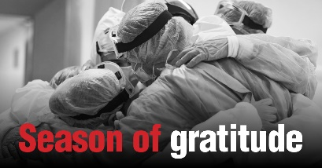
- It’s the season of gratitude, once again.
This season of gratitude, remember to thank your hospitals and health care workers, who have faced significant challenges every single day for nearly two years. They’ve been committed to you, and now you can show your commitment to them by wearing masks, washing hands, watching distances, and waiting to attend large gatherings.

- This season of gratitude let’s celebrate our heroes.
As many of us prepare for a more traditional holiday season, our health care workers are facing challenges both old and new. As many of us look forward to relaxing with loved ones, our hospital staff are planning to care for strangers. Let’s remind them that they are still heroes, and that we’re just as grateful as we’ve ever been.

Calls to action:
- Everyday preventative actions that can help fight germs like flu: https://www.cdc.gov/flu/pdf/freeresources/updated/everyday-preventive-actions-8.5x11.pdf
- Learn more about seasonal flu vaccines: https://www.cdc.gov/flu/prevent/flushot.htm
- Find out who should get a flu vaccine: https://www.cdc.gov/flu/prevent/vaccinations.htm
- FACTSHEET: Who should get the flu vaccine and who should not? https://www.cdc.gov/flu/pdf/freeresources/updated/who-should-vaccinate-update.pdf
- Misconceptions about seasonal flu and flu vaccines: https://www.cdc.gov/flu/prevent/misconceptions.htm
- Learn about the threats posed by an upcoming flu season amid another COVID-19 surge: https://www.aha.org/double-impact-bracing-flu-season-and-covid-19
- FACTSHEET: Get a flu shot during COVID-19! https://apic.org/wp-content/uploads/2020/09/Factsheet_FluShot3.pdf
- Understanding similarities and differences between flu and COVID-19: https://www.cdc.gov/flu/symptoms/flu-vs-covid19.htm
- Answers to questions about the COVID-19 vaccine: https://www.aha.org/vaccine
- Find out where to get the COVID-19 vaccine: https://covid19.colorado.gov/vaccine/where-you-can-get-vaccinated
- Find out why frontline workers get the COVID-19 vaccine: https://www.aha.org/mywhy

